H.T No
Regulations:
A20

Sreenidhi Institute of Science and Technology
(An Autonomous Institution)
Code No: 8AC48 Date: 13-July-2023 (FN)

B.Tech III-Year II- Semester External Examination, July - 2023 (Regular)
ELEMENTS ELECTRICAL AND ELECTRONICS ENGINEERING - (CIVIL)

Time: 3 Hours Max.Marks:70

Note: a) No additional answer sheets will be provided.
b) All sub-parts of a question must be answered at one place only, otherwise it will not be valued.
c) Missing data can be assumed suitably.

Bloom's Cognitive Levels of Learning (BCLL)

Remember | L1 | Apply | L3 | Evaluate | L5
Understand | L2 | Analyze | L4 | Create | L6

Part - A Max.Marks:20
Answer all QUESTIONS

 |  | BCLL | CO(s) | Marks
1 | If three resistors are in parallel with 20ohm, 25ohm and 50ohm, Calculate the equivalent Resistance. | L3 | CO1 | [2M]
2 | Define the peak factor of sine function. | L1 | CO2 | [2M]
3 | State faraday’s law of electro-magnetic induction. | L2 | CO3 | [2M]
4 | Write the difference between clipper and clamper circuit. | L1 | CO4 | [2M]
5 | What is BJT and write the types of BJT. | L1 | CO5 | [2M]
6 | List out the universal logic gates? Why are they so called? | L1 | CO6 | [2M]
7 | Define term j operator. | L1 | CO2 | [2M]
8 | Write an expression for the slip of an induction motor. | L1 | CO4 | [2M]
9 | Draw the characteristics of BJT in common collector configuration. | L1 | CO6 | [2M]
10 | State Kirchhoff’s voltage law. | L2 | CO3 | [2M]
Part – B Max.Marks:50
ANSWER ANY FIVE QUESTIONS. EACH QUESTION CARRIES 10 MARKS.

 |  |  | BCLL | CO(s) | Marks
11. | a) | Calculate the equivalent resistance for the given circuit shown in figure below ?  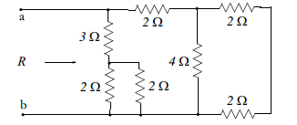 | L3 | CO1 | [5M]
 | b) | Differentiate resistor, inductor and capacitor elements using their voltage-current characteristics. | L4 | CO1 | [5M]
12. | a) | Calculate average value of sinusoidal waveform shown in figure below  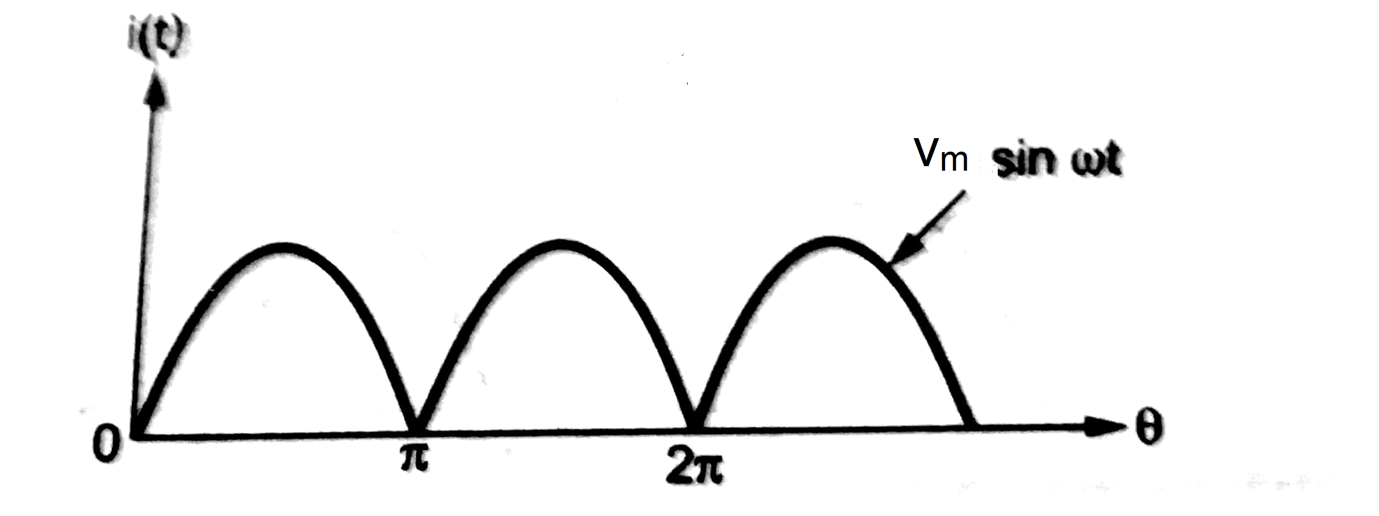 | L3 | CO2 | [5M]
 | b) | Define the terms peak, peak to peak, average, RMS values, form factor of sine wave. | L1 | CO2 | [5M]
13. | a) | Describe the principle of operation of three phase induction motor. | L1 | CO3 | [5M]
 | b) | With the help of the neat sketch Explain the working of a moving iron (MI) instrument? v_{m} | L2 | CO3 | [5M]
14. | a) | Draw and Explain the operation of PN junction diode characteristics | L1 | CO4 | [5M]
 | b) | Define a filter and discuss various classification of filters? | L1 | CO4 | [5M]
15. | a) | Explain the BJT operation in common base configuration with neat sketch? | L2 | CO5 | [5M]
 | b) | Draw the characteristics and Explain the working principle of JFET. | L1 | CO5 | [5M]
16. | a) | Draw the symbols and truth tables of AND, OR, NOT gates. | L1 | CO6 | [5M]
 | b) | Convert the following  - (0110)₂ to decimal system (ii) (127)₁₀ to octal | L5 | CO6 | [5M]
17. | a) | Explain super position theorem with an example. | L2 | CO1 | [4M]
 | b) | Analyze the behaviour of single phase circuit with pure resistor. | L4 | CO2 | [3M]
 | c) | Give the classification of electrical measuring Instruments. | L2 | CO3 | [3M]
18. | a) | Draw and Explain Zener Diode Characteristics. | L1 | CO4 | [4M]
 | b) | Differentiate between BJT and MOSFET. | L4 | CO5 | [3M]
 | c) | Solve the expression using k map : Y=A'B' + A'B+AB. | L3 | CO6 | [3M]

-- 00 -- 00 –

